Prepare a model for strength of concrete data using Neural Networks

**Ans :**

**R Code :**

## Neural Network

########## Concrete Data Set #########

concrete <- read.csv('D:\\Data Science\\Excelr\\Assignments\\Assignment\\Neural Networks\\concrete.csv')

# custom normalization function

normalize <- function(x) {

return((x - min(x)) / (max(x) - min(x)))

}

# apply normalization to entire data frame

concrete_norm <- as.data.frame(lapply(concrete, normalize))

# create training and test data

concrete_train <- concrete_norm[1:773, ]

concrete_test <- concrete_norm[774:1030, ]

## Training a model on the data ----

# train the neuralnet model

library(neuralnet)

# simple ANN with only a single hidden neuron

concrete_model <- neuralnet(formula = strength ~ cement + slag +

ash + water + superplastic +

coarseagg + fineagg + age,

data = concrete_train)

# visualize the network topology

plot(concrete_model)

## Evaluating model performance ----

# obtain model results

model_results <- compute(concrete_model, concrete_test[1:8])

# obtain predicted strength values

predicted_strength <- model_results$net.result

# examine the correlation between predicted and actual values

cor(predicted_strength, concrete_test$strength)

## Improving model performance ----

# a more complex neural network topology with 5 hidden neurons

concrete_model2 <- neuralnet(strength ~ cement + slag +

ash + water + superplastic +

coarseagg + fineagg + age,

data = concrete_train, hidden =c(5,2))

# plot the network

plot(concrete_model2)

# evaluate the results as we did before

model_results2 <- compute(concrete_model2, concrete_test[1:8])

predicted_strength2 <- model_results2$net.result

cor(predicted_strength2, concrete_test$strength)

**Results :**

> cor(predicted_strength, concrete_test$strength)

[,1]

[1,] 0.8055356

> cor(predicted_strength2, concrete_test$strength)

[,1]

[1,] 0.9260496

**Plots :**

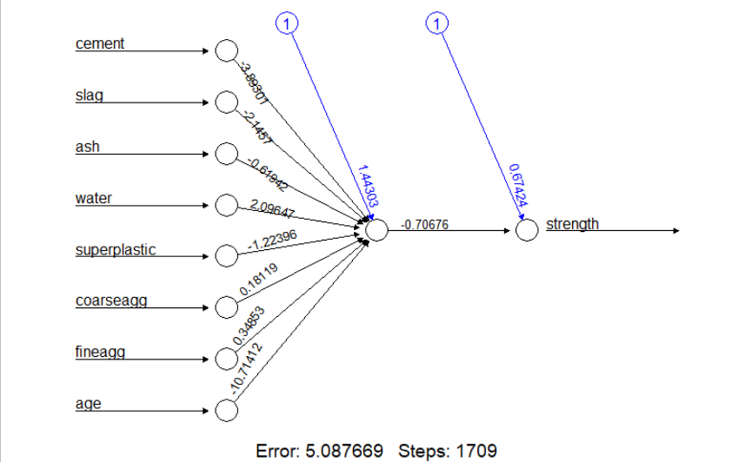

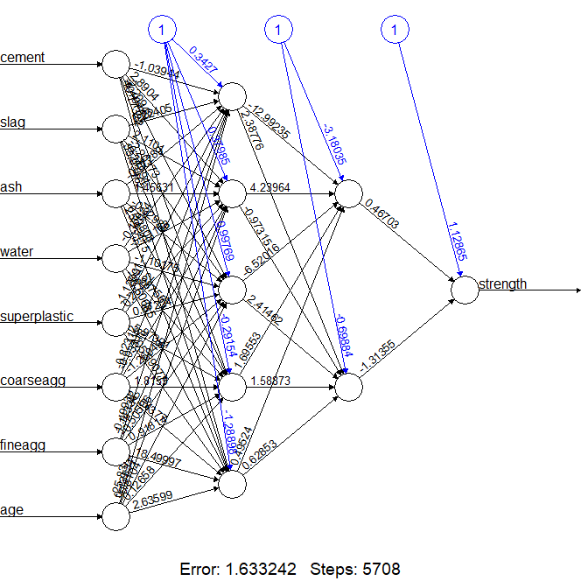

**Inference :**

Getting more accuracy with the extra hidden layers.